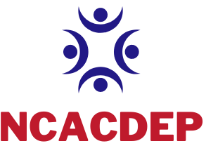

North Carolina Association of Community Development Extension Professionals

2022 DUES and MEMBERSHIP INVOICE

Member Name: ________________________ County/State Office/Etc.:________________

Address: _____________________________________________________________________

Email Address: ________________________________ Phone: _______________________

*All Dues include membership for the National Association. This is required as part of our Chapter Affiliation.

Please select:
_____ State/National - $115- ( $25- State and $90 National)

_____ State Only - $25 – (Evidence of Paid National Membership MUST be Included)

_____ Affiliate – $115 (Includes $90 National)
TOTAL Due $___________
_____ Student - $35- (Includes $25 National)

_____ Life/ Retiree Membership - $300 (no cost for State life in 2022- only National fees.)

ALL members paying state and national dues together must submit a printed invoice from NACDEP for your national dues. If you are renewing NACDEP, print the invoice you received by email or go to your NACDEP profile for a copy. If you are a new national member, complete the registration at www.nacdep.net and select “send check.” The association administrator will provide an invoice to you. Attach the invoice to this form and submit payment for both State and National in one check to NCACDEP.
(If you have already paid National fees online, please deduct this amount before sending and include your receipt for payment.) We will submit payment to National as one lump sum for all members not paying with Credit Card.

**This form, along with the National Invoice and your check for dues should be mailed to: Payable to: NCACDEP Send to: Kittrane Sanders (Treasurer), 126 Alexander Dr. Suite 300 Lillington, NC 27546

